DATA SHARING
As we had seen how to share tables, external tables & UDF’s in earlier posts via sql commands & UI
Let’s see how to share Database to reader/consumer account and see different operations on how it reflects from provider to consumer account
Create a share in main/provider account
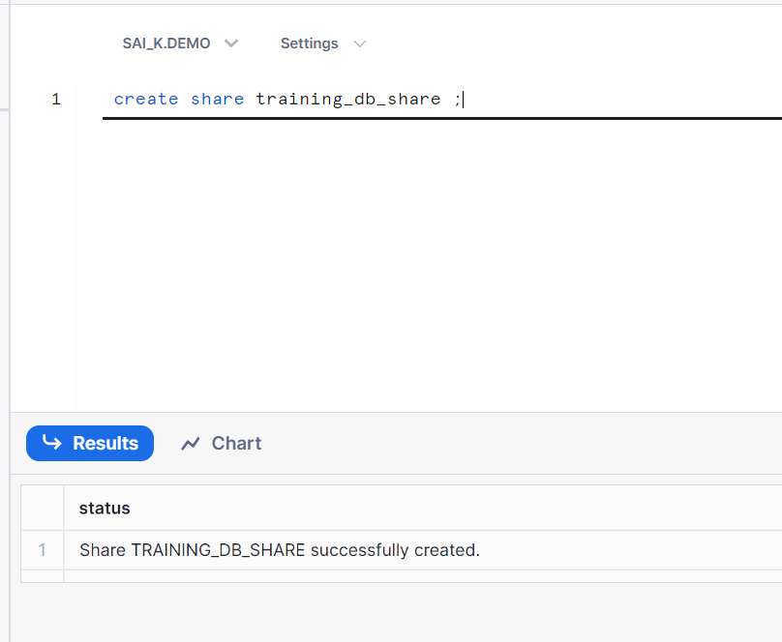
Give grants on existing data base and schema to share
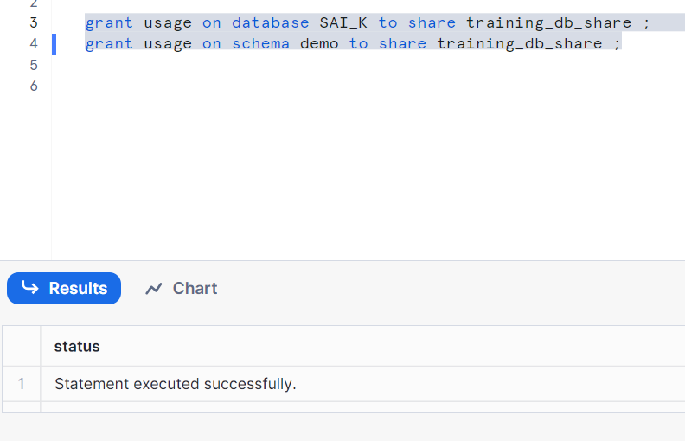

Creating and inserting table items
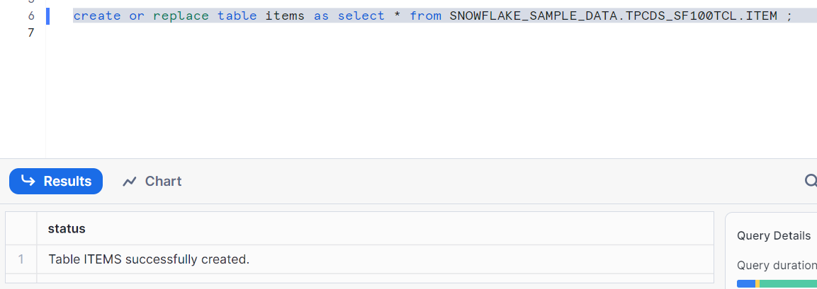
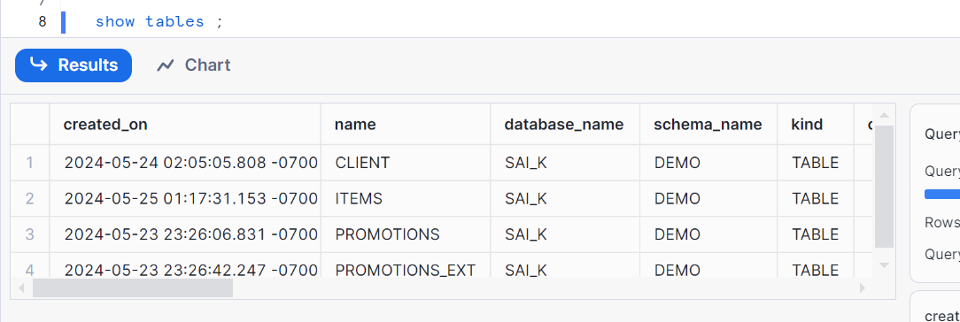
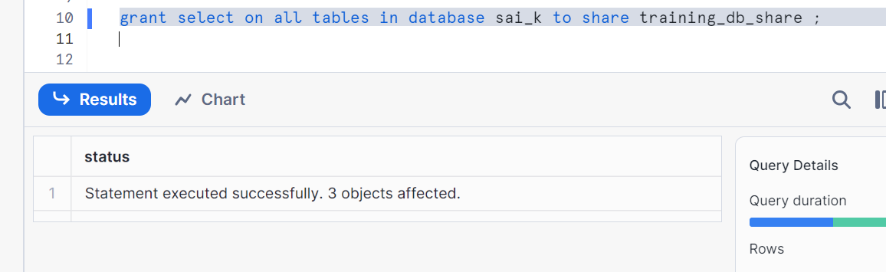
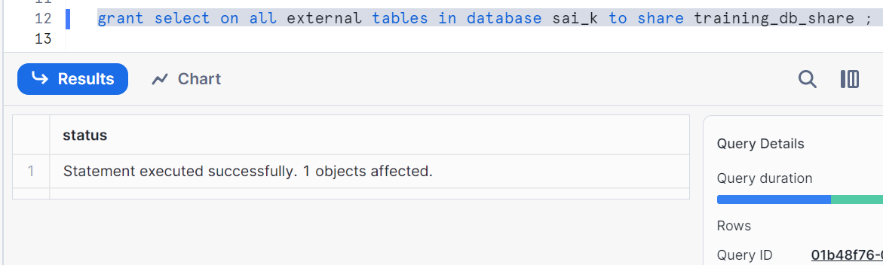
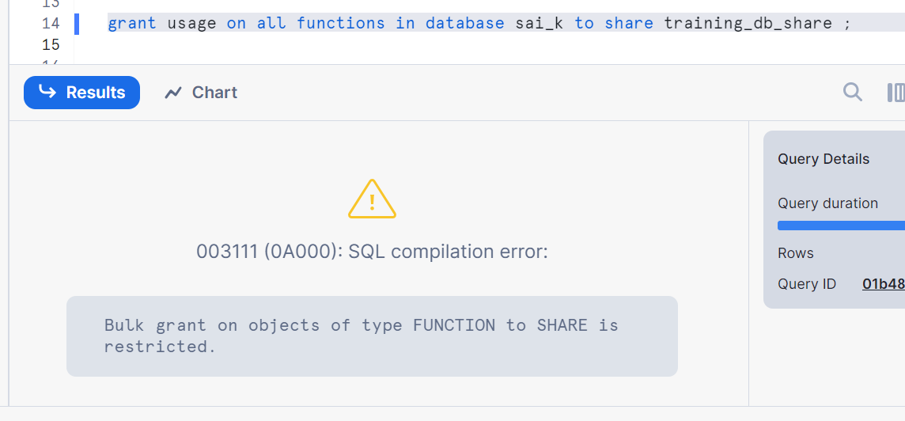
Hence, we had to grant individually on a function
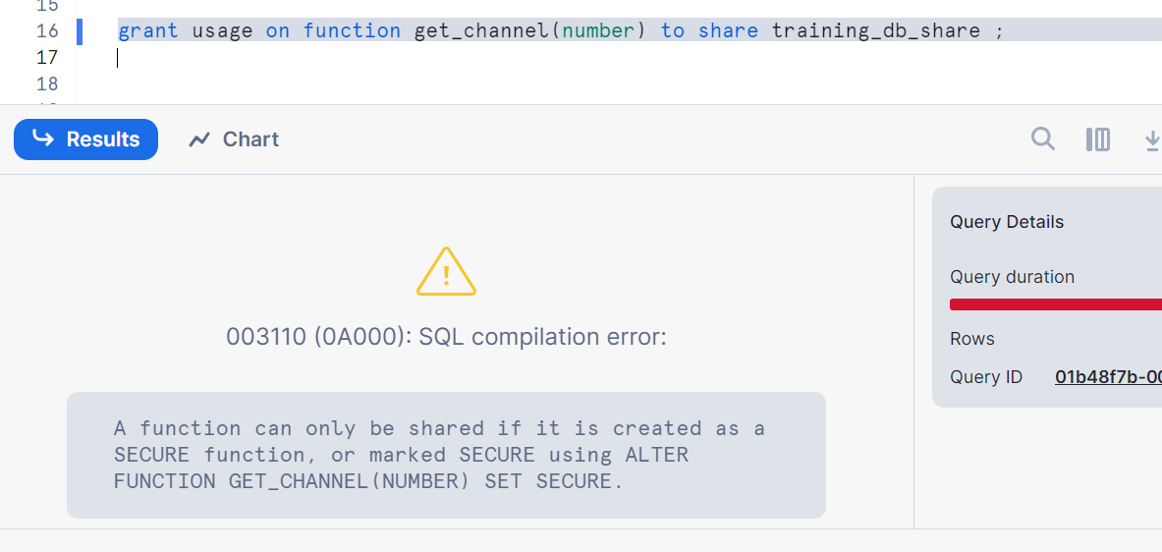

Hence, setting secure
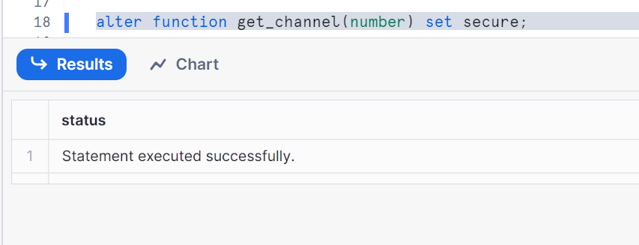
Now let’s run
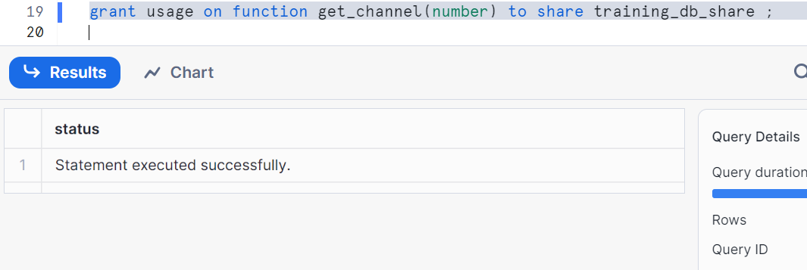
Add reader/consumer account to share
Note: copy your locator of reader account and paste as shown
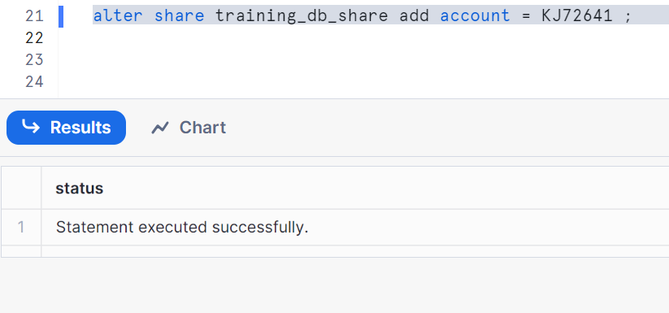
Go to you reader account and check the following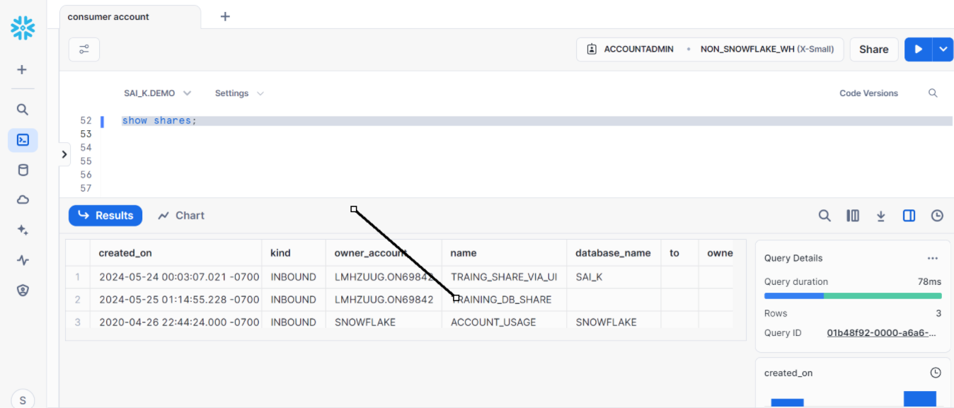

Create a database using the share
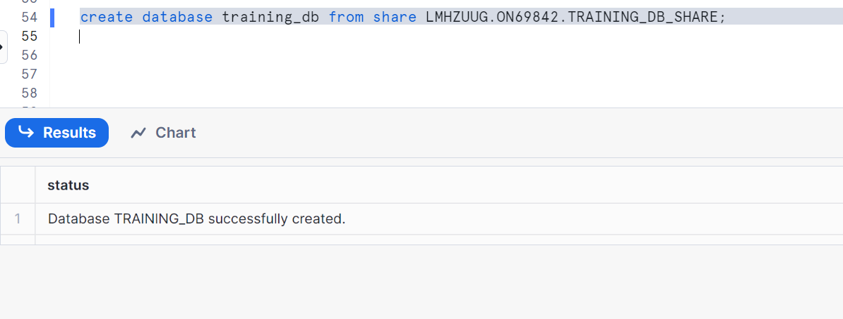
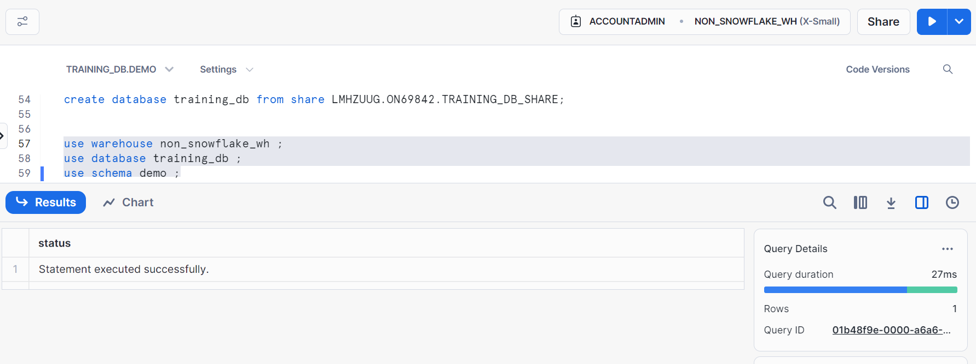

Check all the following
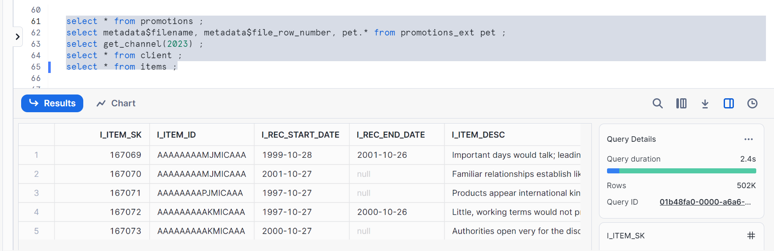

Data share Operations:
We can see 5 records in both provider and reader account in table client
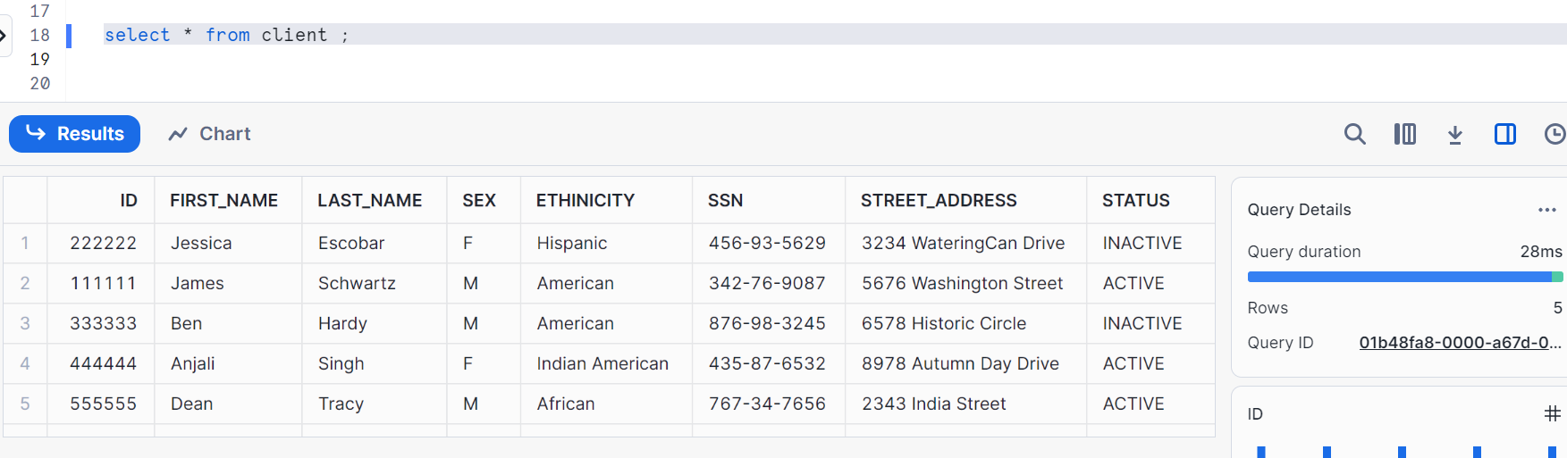
Let’s insert some records in provider account and see whether it is reflecting in reader account
Go to provider account and add records as shown
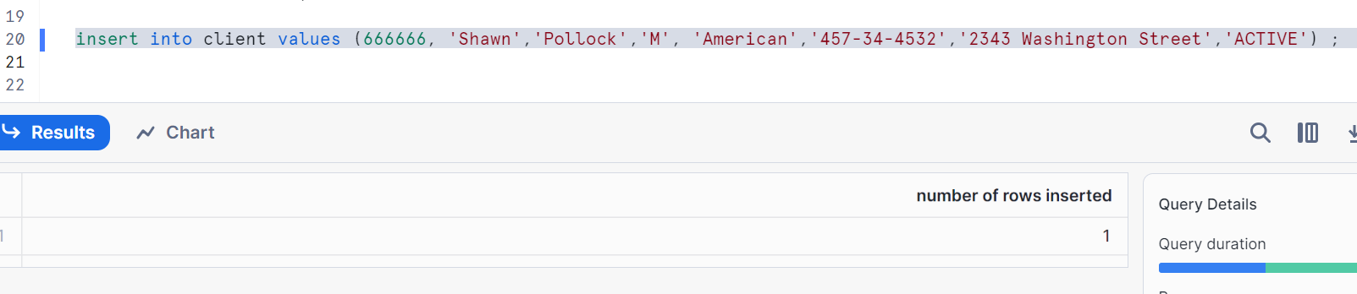
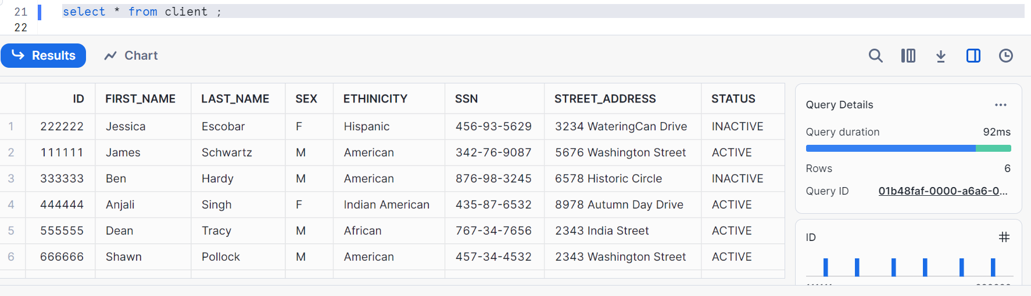
Let’s check in reader account
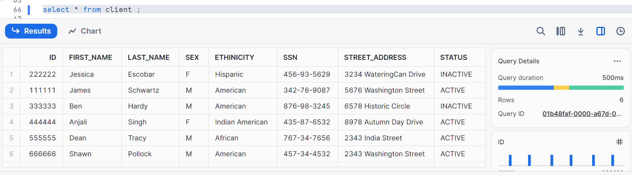
Let’s delete in provider account
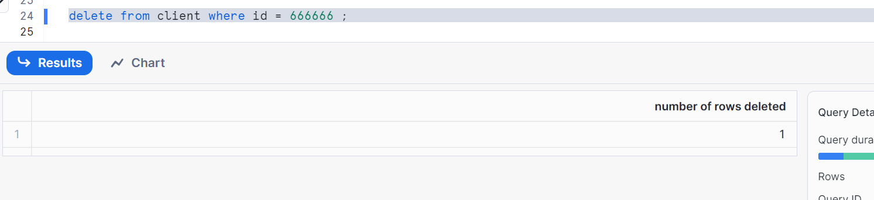
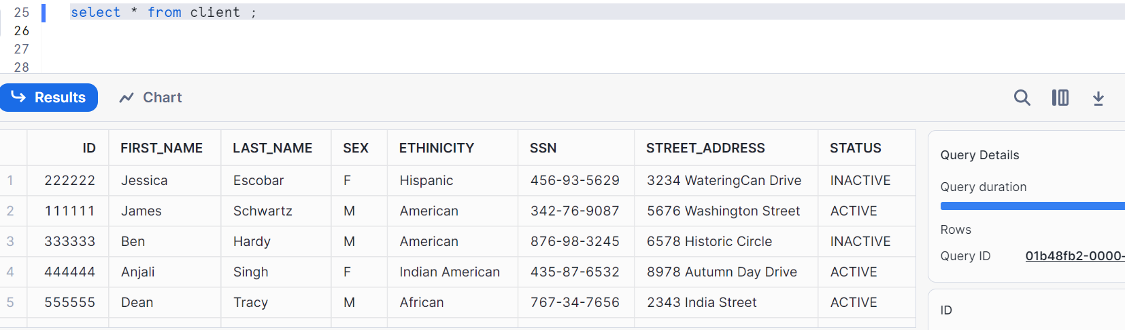

Check in reader account
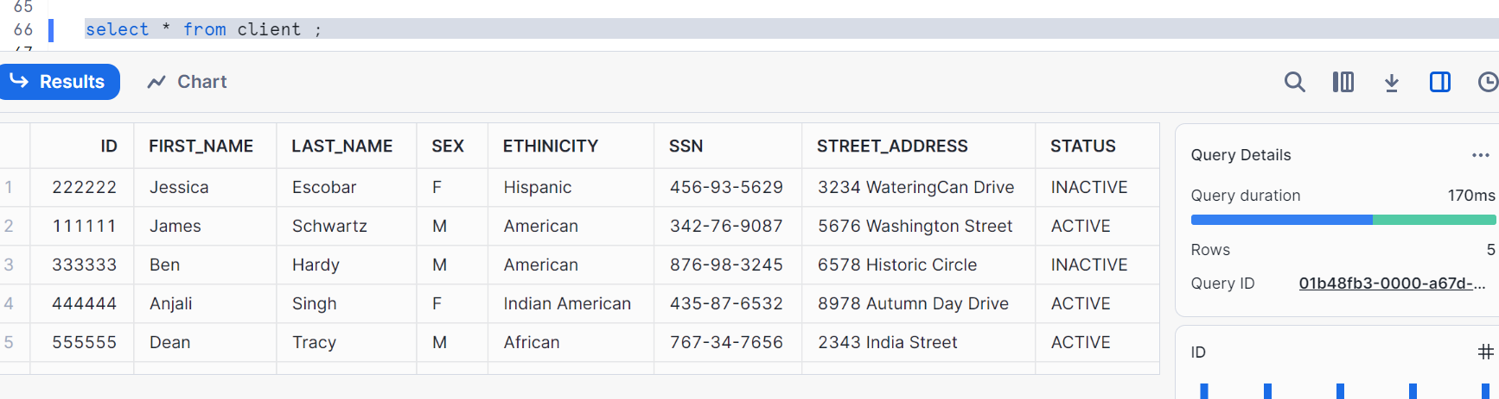
Hence, insert and delete operations are reflected in reader account
Let’s do update operation in provider account
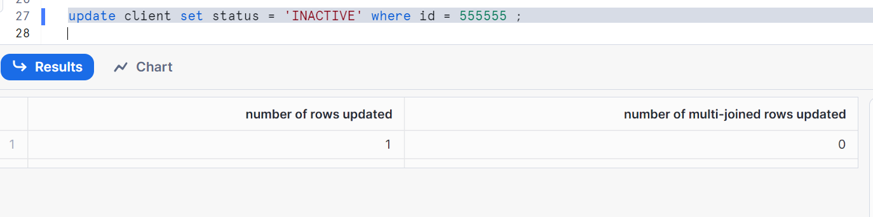
Check in reader account
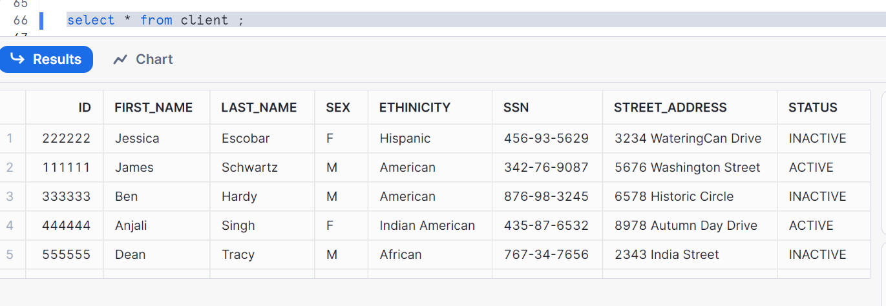
Update operations are reflected in reader account

Create a table in provider account
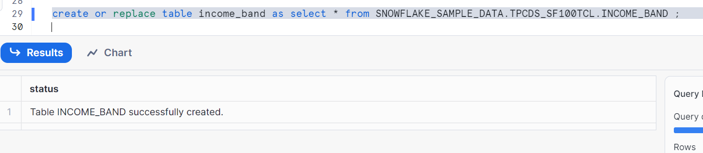
Check in reader account
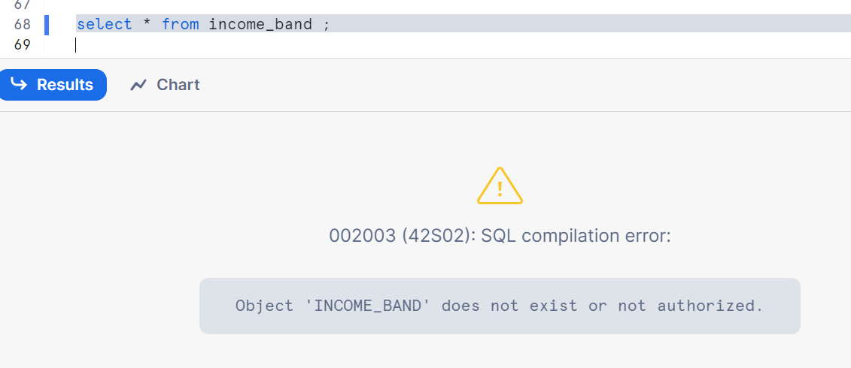
Hence, even if you shared you entire database to your consumer/reader account, you need to provide particular object grant again to entire DB share
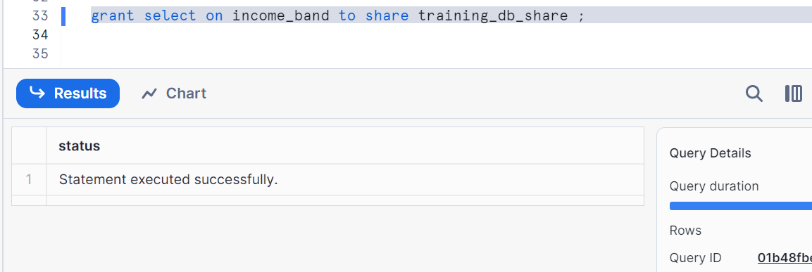

Check in reader account
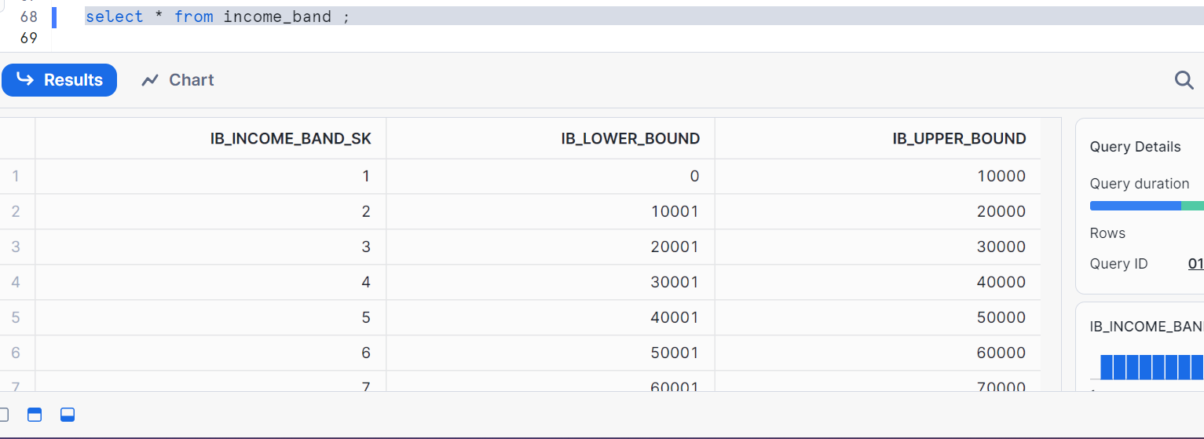
Conclusion: DML operations reflects in reader but DDL operations needs grant to reflect

Sharing views and materialized views:
Go to your provider account and create a view
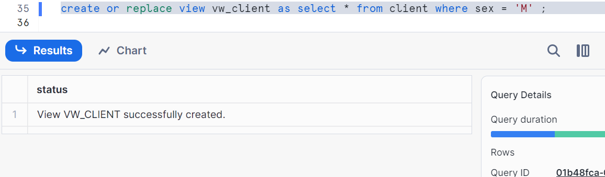
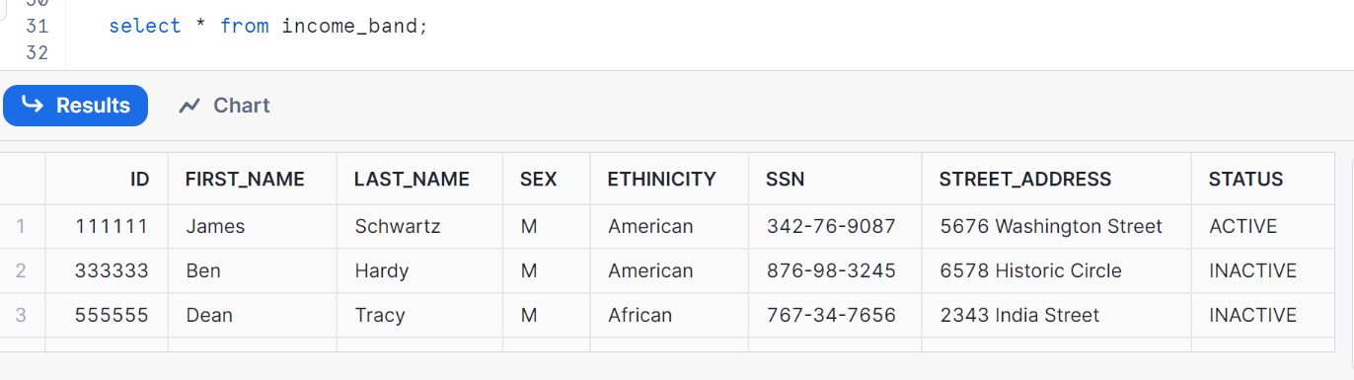

Giving grant
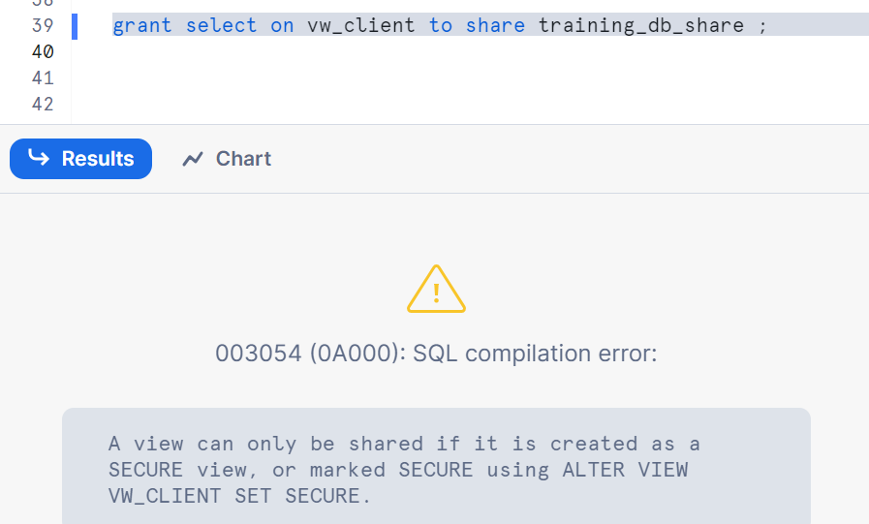
Hence, let me create a secure view
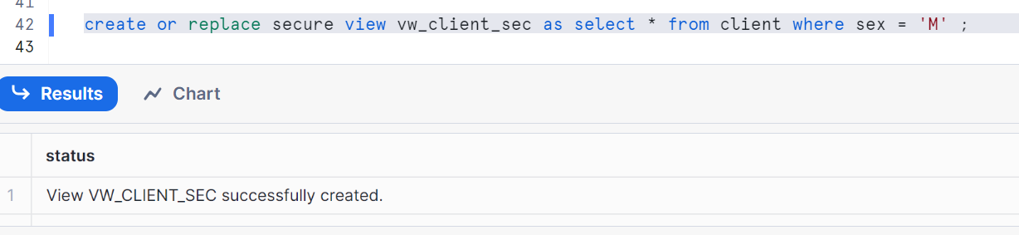
Granting to role public
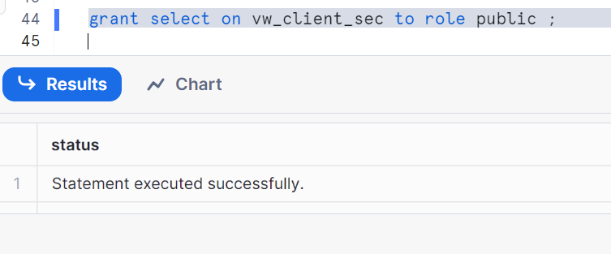

Let’s see the data
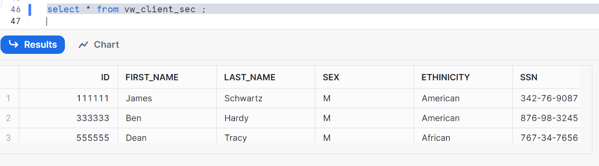
Observe the difference as shown
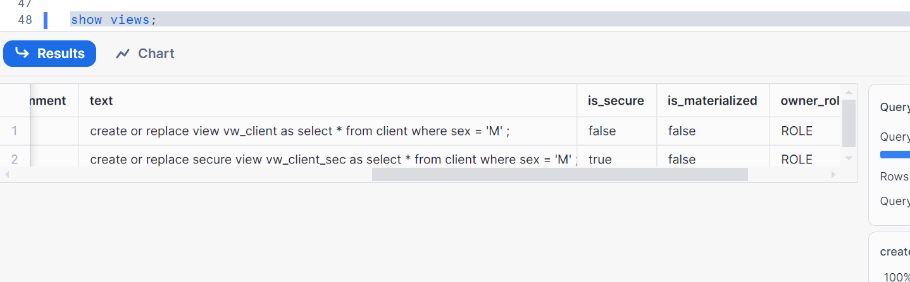
Now change the role to public and check
You can see text/body is not present
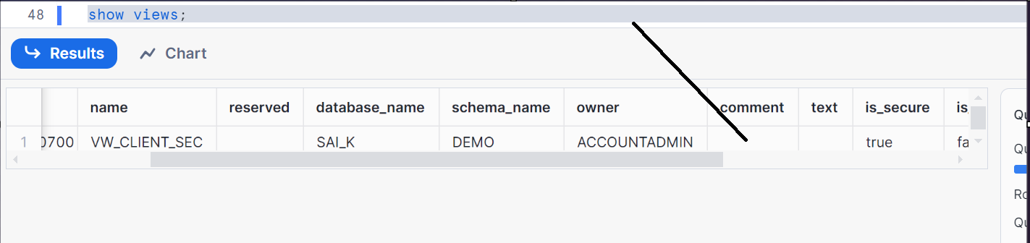
To still see the difference clearly, go to account admin role and run the below
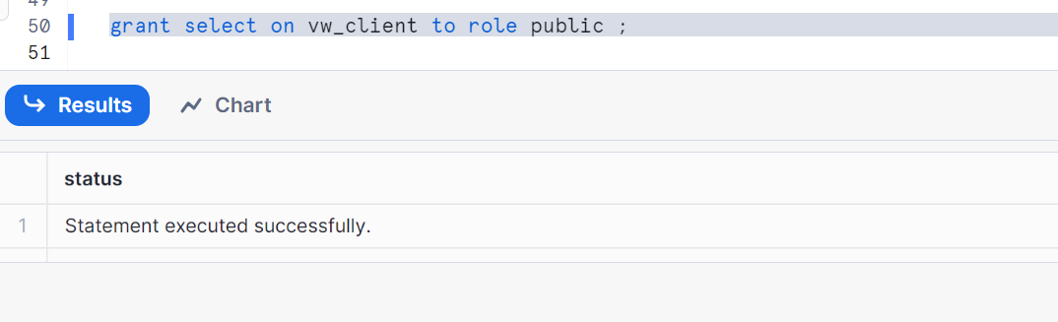
Go to pubic and check again
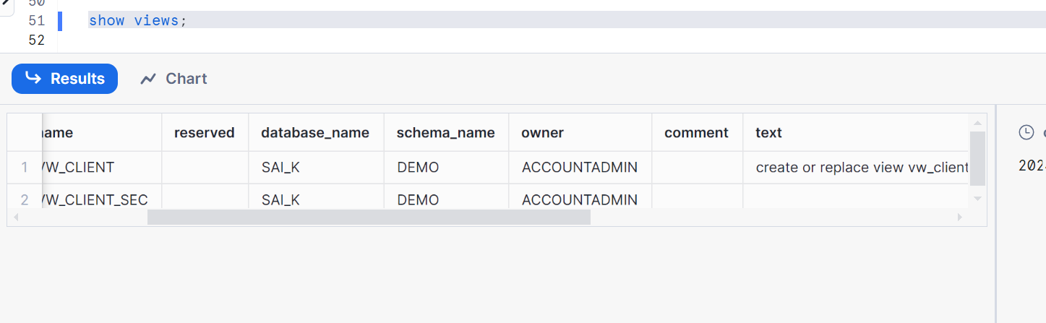
Hence you can understand the difference of view and a secure view
Now, go to account admin and give grant
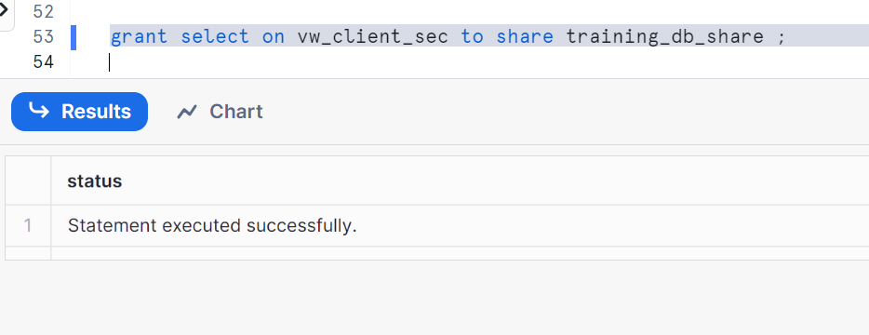
Now, let’s check in reader account
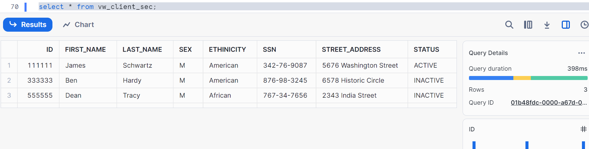

Let’s create a materialized secure view and demonstrate
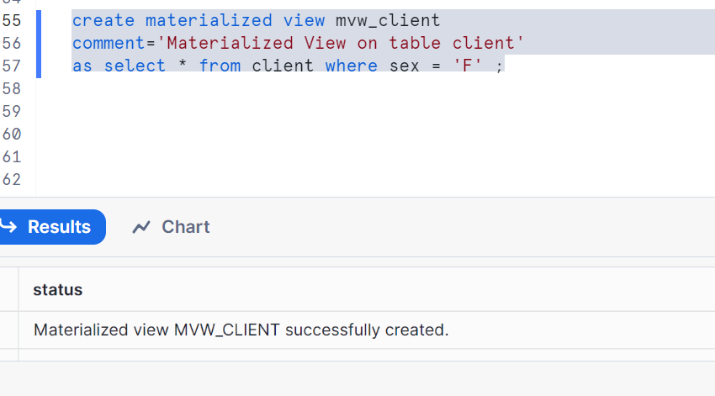
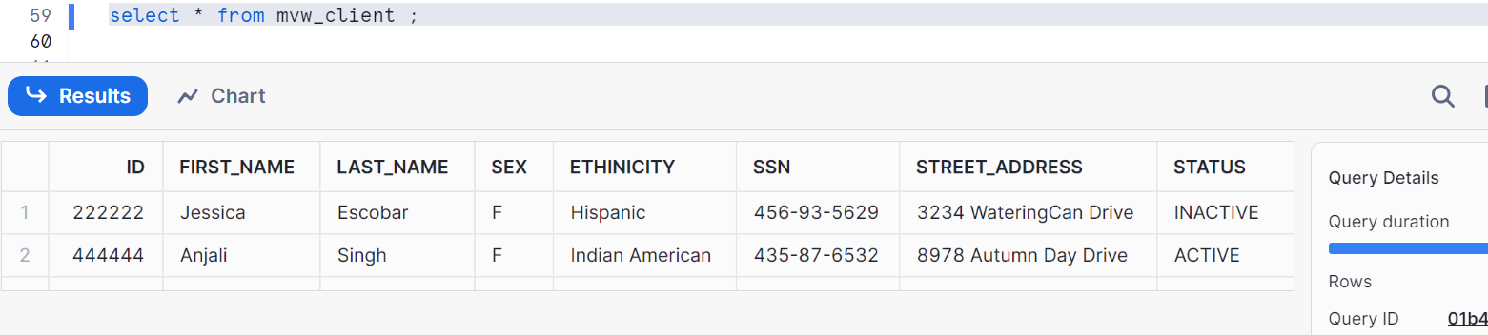
Materialized view is not secured
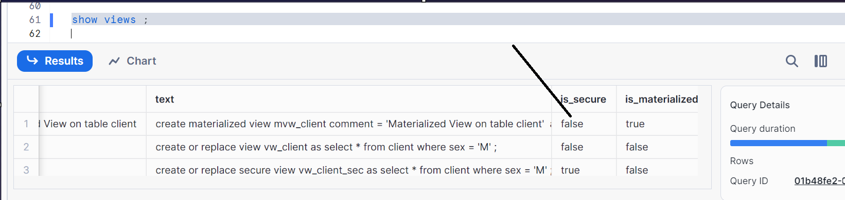

Let’s alter to set secure
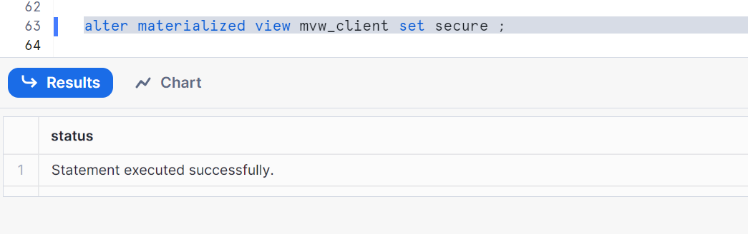
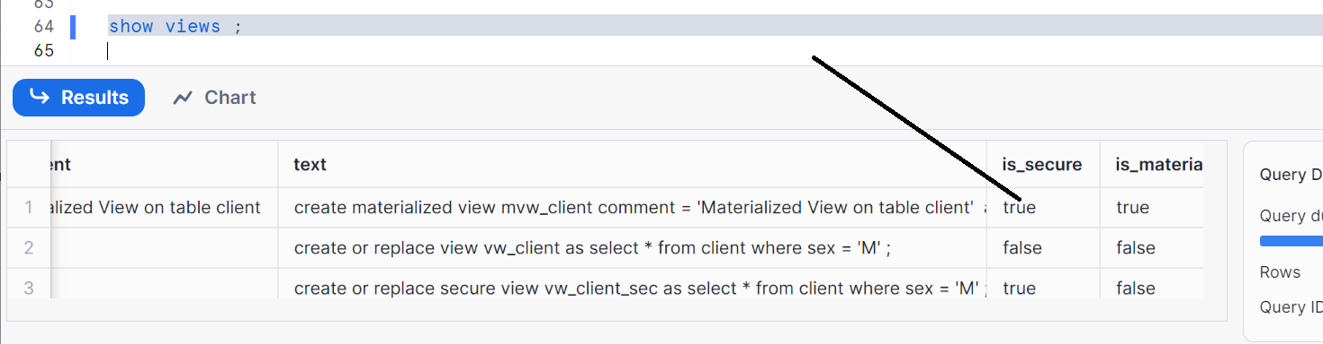

Grant materialized view to share
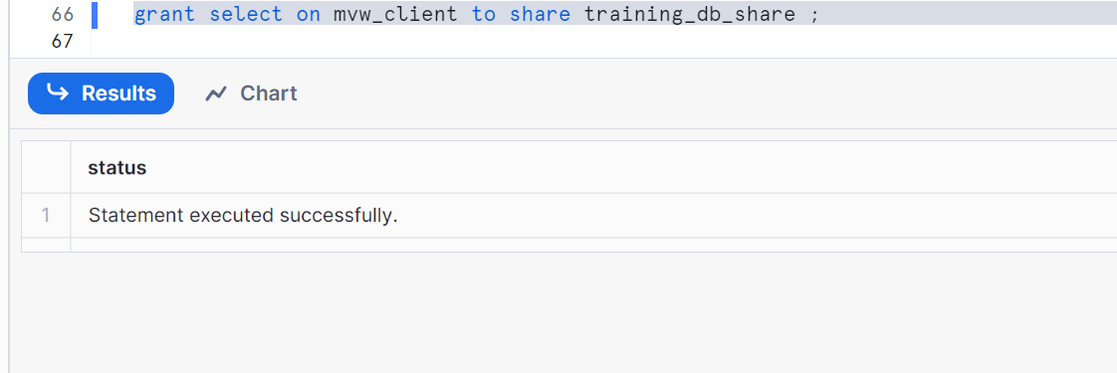

Let’s go to reader account and check
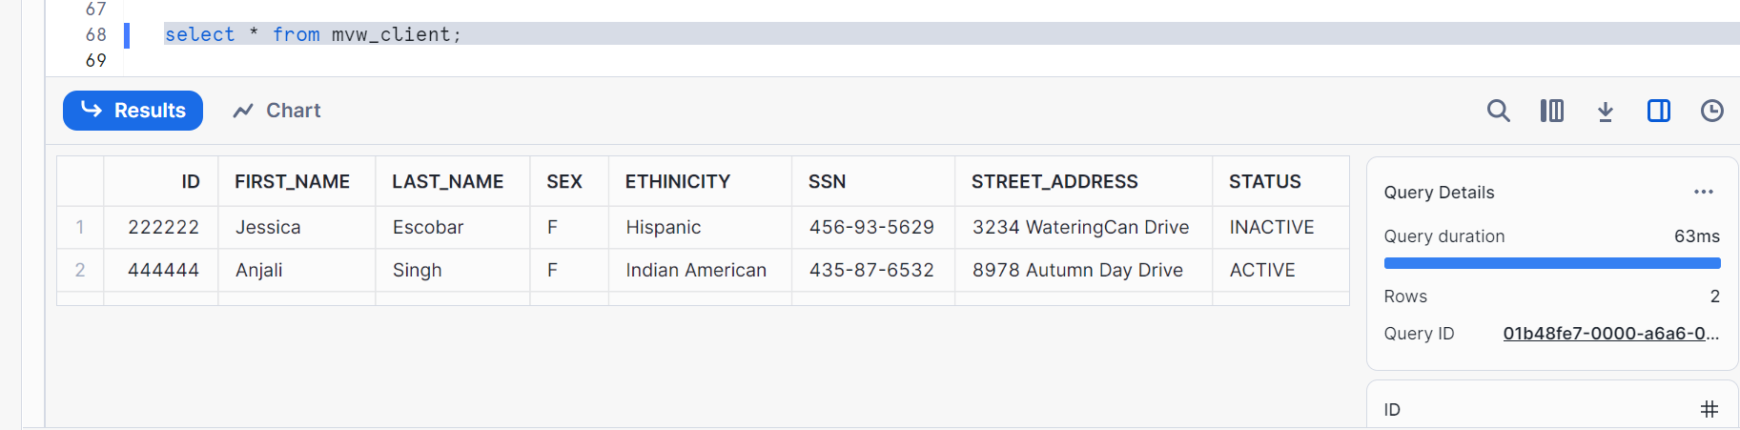

If you want to update anything in your reader account, it doesn’t allow as its ‘ready only’ account
